Hair Care Project Proposal

Xannia Simpson, Manofi Kone, Ifeoluwa Akinrelere

# Application Description

This application takes information from the user about their hair (Hair type and Hair Porosity). After it receives this information, it will provide the user with information on products that best help with Dryness, Split End Repair, and Moisture Retention.

# Project Objectives

# This project aims to create a program that makes it easier for women of all hair types to find the right product for them—allowing them to target any and all issues that they may be experiencing with their specific hair types.

# Background:

For years, women have struggled to find the right products for their hair textures, whether they were a “3a” texture (lighter curl pattern) or a “4c” texture (kinky—coily curl pattern). Our program aims to make it easier for women of all hair types to find the right product for them.

# Algorithm Development

#### Main Algorithms:

1. Input Collection Algorithm
   * Collect user input for hair type, porosity, and products used.
   * Validate inputs against predefined acceptable values (e.g., hair types: 3A, 3B, etc.).
2. Data Matching Algorithm
   * Match the user's hair type to a predefined array of recommended products based on their hair characteristics.
3. Output Generation Algorithm
   * Display the matched product recommendations and any additional information based on user input.

# Wireframe (optional)

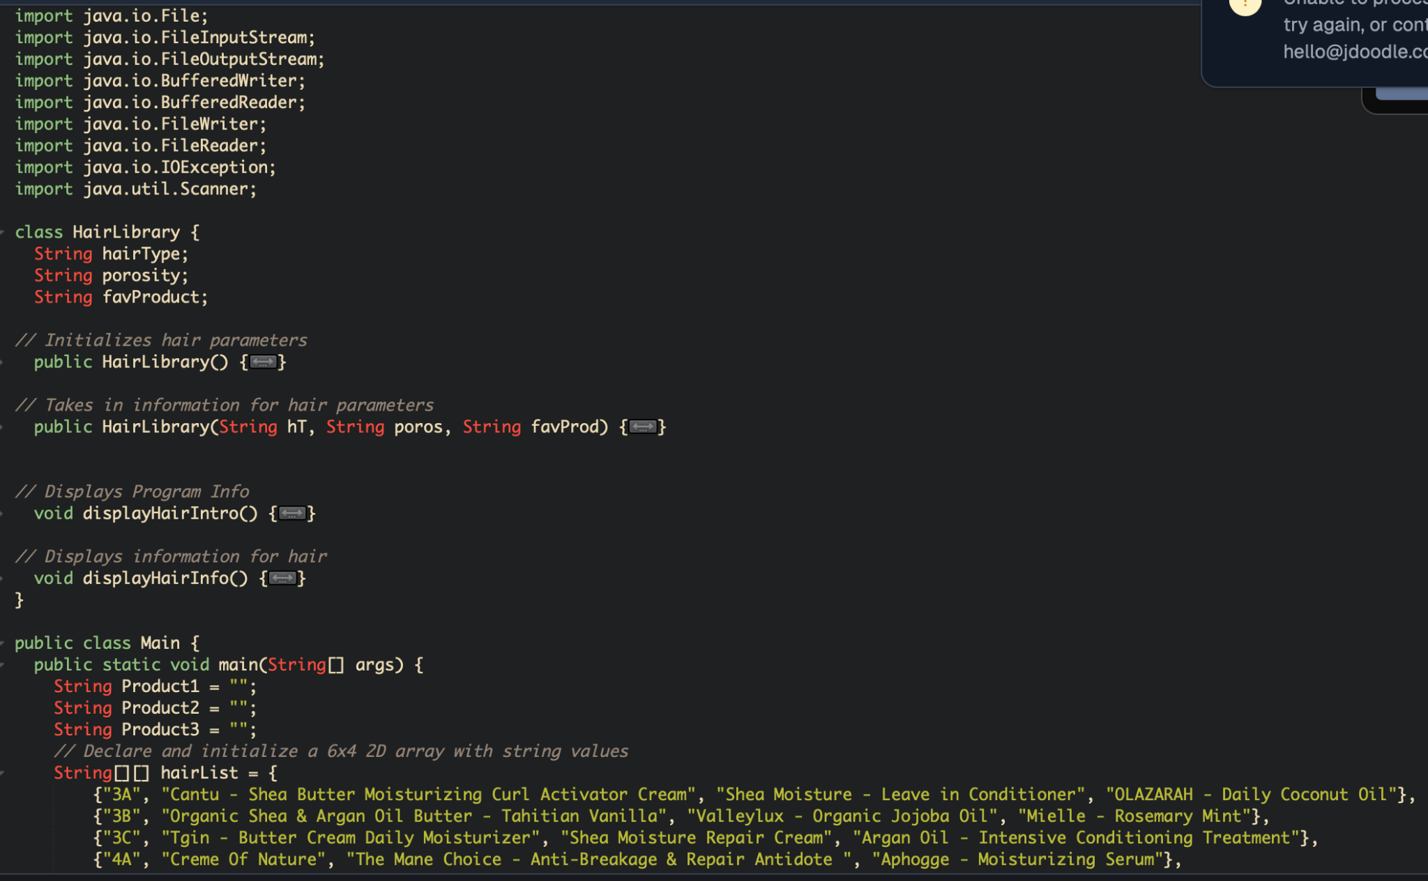

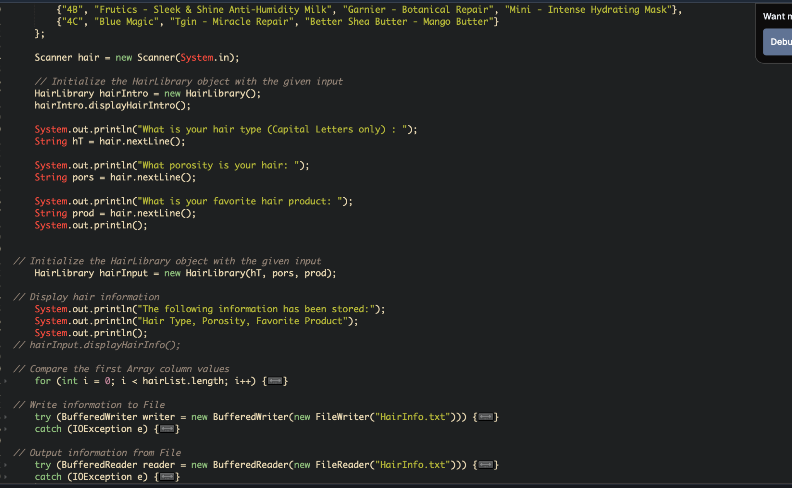



# Scope Of Work

Tasks:

1. Define Hair Care Class Structure
   * Create a class with attributes: hairType, porosity, productsUsed.
   * Include getters, setters, and constructors.
2. Implement Input Collection Method
   * Design a method to ask questions and collect user input.
3. Match Input to Recommendations
   * Implement logic to match hairType to recommendations in the array.
4. Display Recommendations
   * Provide output with suggested products based on hairType.
5. Testing
   * Test the program with different inputs to ensure proper matching and output.

#### Milestones:

* Day 1-2: Create the basic class structure and initialize variables.
* Day 3: Implement methods for input collection and validation.
* Day 4: Write the logic for matching hairType to the recommendations array.
* Day 5: Test, debug, and finalize the program.

# Features

List key features of the application.

# Success Measures

The project's success will be measured by functional accuracy, user access and experience, and data management.

# 

# Resources

* Java IDE( Jdoodle and Visual Studio)
* Github.

# Concepts

The course concepts applied to this project were:

* Classes
* Parametrized Constructors
* Methods
* Arrays
* File Input and Output
* Scanners

# Third-Party Libraries

No external libraries are used for this program.

# Non-Standard GUI Design

There were no custom GUI designs.

# Image Repository

Visual assets are in PowerPoint most images came from Google.